FreeAgent registration

Made 10.09.2018.

To use the API of FreeAgent you will need to generate API credentials.

1. Go to the FreeAgent Developer Dashboard page <https://dev.freeagent.com> and click Sign Up.

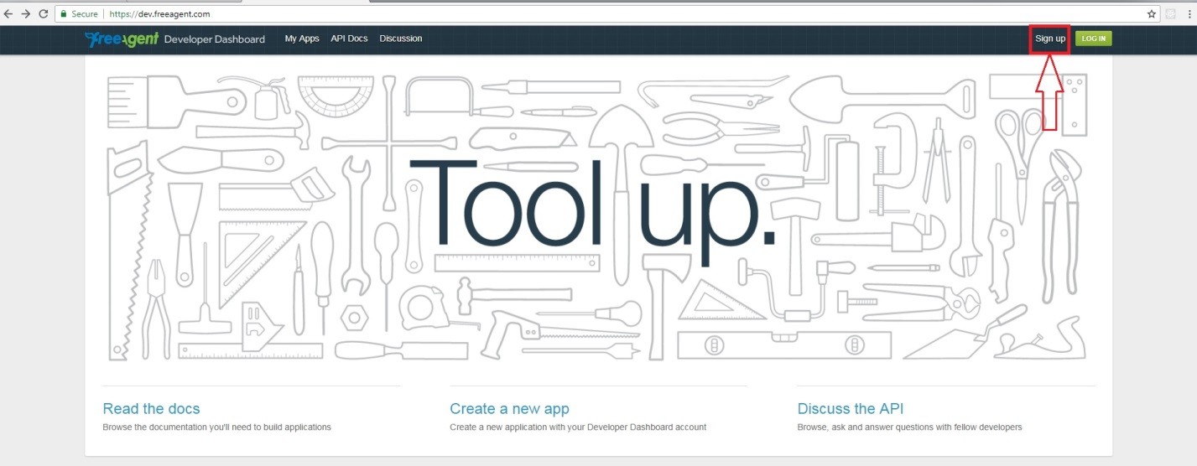

1. Enter information about your Developer Dashboard account and click Sign up.

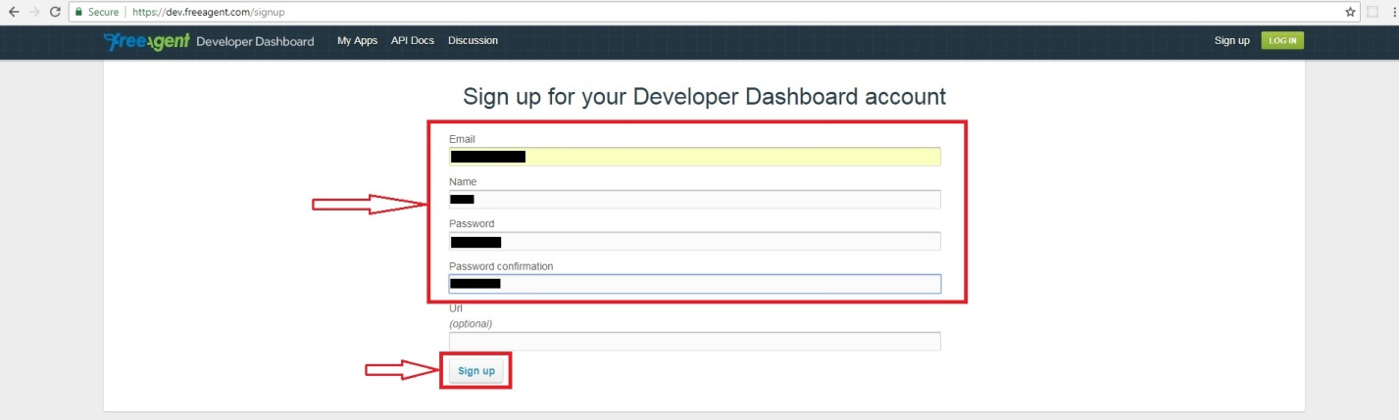

1. Click on button Create New App.

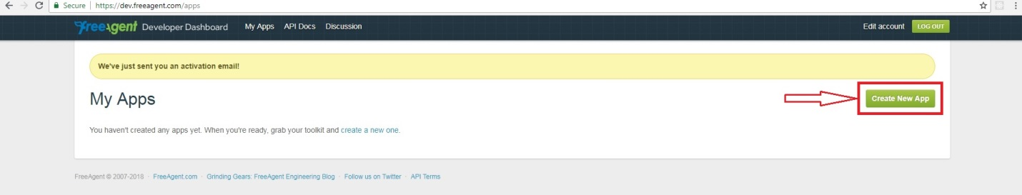

1. Enter information about your App and click Create App.

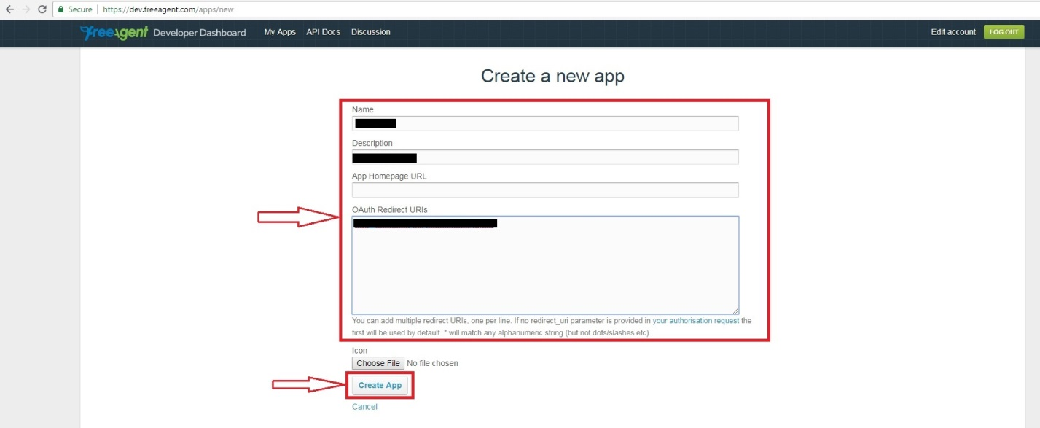

1. Your OAuth identifier and OAuth secret.

